MODEL QUESTIONS
- Explain the difference between total and partial participation constraints.
- What are the various types of keys with suitable examples
- Mention the significance of descriptive attributes with proper examples
- Differentiate between schema with instance
- Explain the responsibilities of DBA
- What is data independence? Explain its types
- How equi join is different from natural join? Specify with examples
- Write the SELECT command of SQL with syntax
- Write the Projection operation used in relational algebra with syntax
- Write down the Armstrong’s Axioms
- For a given set of FDs F={A->B, A->C, CG->H, CG->I, B->H}, Compute F⁺
- Find out the candidate keys for a relation R(ABCDEFGH) with the given FDs F={A->C, B->D, G->H, E->F, C->G}
- Define the term Concurrency in transaction. Why concurrency control mechanism is needed?
- Write ACID properties of transaction
- What is conflict serializability
- Write about the anomalies of hierarchical model.
- Define data dictionary
- Differentiate between strong and weak entity set with suitable example
- What are the responsibilities of DBA in database system.
- Write down the different types of attributes in ER models with suitable examples

Possible long questions

- Define data model. Describe the different record based data models with suitable examples
- Define DBMS. Discuss the advantages of database system over traditional file processing system
- Draw and explain the three schema architecture in database design. Write the importance of data abstraction in DBMS.
- Explain about different types of database integrity constraints?
- Draw the ER diagram for the following descriptions
A Company contains several Departments. Each Department have several Locations. Departments are identified by a department name, Department no and Department Locations. Managers control a particular department. Each Department is associated with number of projects. Each of which has a unique
name, a unique number, and a single location. Employees are identified by name, id, address, dob, phone no, date_of_joining and years of experience. We will keep track of the direct supervisor of each employee (who is another employee). An employee belongs to only one department but can work on several project. We also keep track of number of hours worked by an employee on a single project. Each employee has dependent. Dependents have D_name, Gender, and relationship.
- Compare and contrast Generalization with Specialization. Draw suitable diagrams for each of them
- Convert the following ER Model into equivalent relational model.
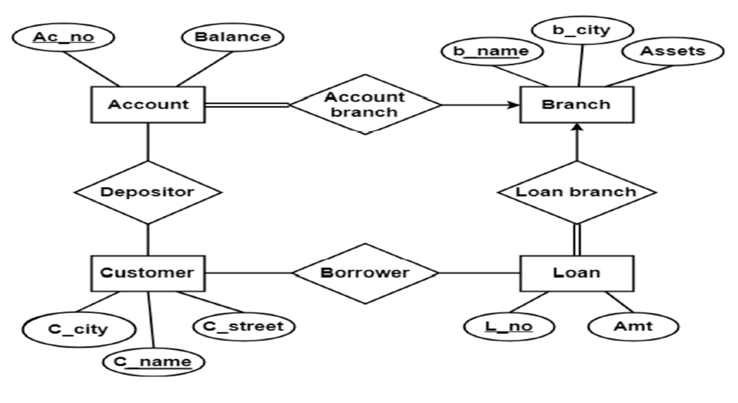

- Solve the following queries by using Relational Algebra and SQL
Suppliers (Sno, Sname, City)
Parts (Pno, Pname, Pcolour)
Supply (Sno, Pno, Quantity)
Find the names of suppliers who supply Red part
Find the names of suppliers who supply some red or green parts
- From the following database schema:
Employee (eid, ename)
Assigned_to (pnum, enum)
Project (pnum, pname, supervisor)
Solve the Queries using Relational Algebra:
i) Retrieve the details of employees who work on ‘Database’ project.
ii) Retrieve the details of employees who work on project number C353.
iii) Retrieve the employee number of employees who work on all projects.
iv) Retrieve the employee number of employees who do not work on project number
C453.
- Explain all the DDL and DML commands of SQL
- Outline the features of SQL. Explain different DDL and DML operations with
- suitable examples.
- Compare Relational Algebra with Relational Calculus. Discuss about Join
- operations with examples.
- What are the advantages of outer join in relational algebra. Explain different outer join operations with suitable examples
- Explain the steps to find minimal cover. Find the minimal cover for the following set of functional dependencies of R (A B C D). F: (A->B, C->B, D->ABC, AC->D)
- State Normalization. Discuss the different normal forms with examples (up to BCNF)
- Explain all the inference rules to infer additional functional dependencies from the given set of functional dependencies. Consider the relation R (A B C D E F G H I J) and the set of functional dependencies F=- {AB->C, BD->EF, AD->GH, A->I, H->J}. Find the key for R. Decompose R up to 3NF.
- Test whether the two given sets of functional dependencies are equivalent or
not?
R (ABCDE)
F= {A->BC, AB->C, D->AC, D->E}; G= {A->BC, D->AE}.
- Define Read and Write operations in a transaction. Draw and explain the state transition diagram of a transaction.
- Differentiate between serial and non-serial schedule in transaction. Briefly explain the different problems that occurs due to concurrent execution of transactions with examples
- Check whether the given schedule S is conflict serializable or not.
S: R₁(A), R₂(A), R₁(B), R₂(B), R₃(B), W₁(A), W₂(B)
Check weather it is view serializable or not
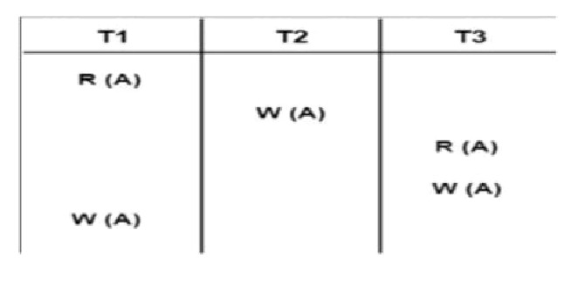

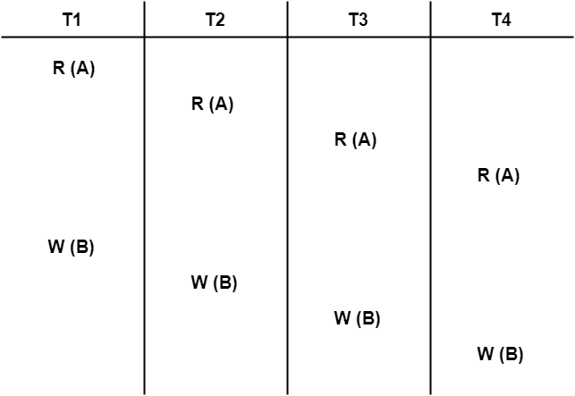
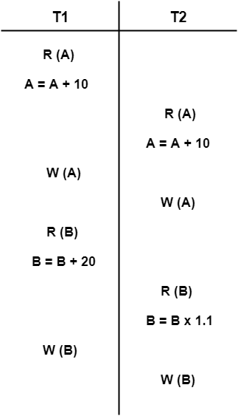
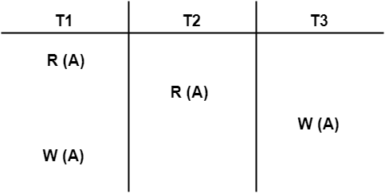
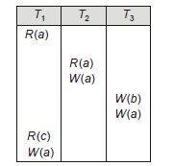
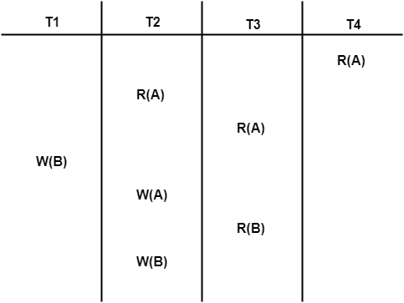
Q. Suppose a relation R (A, B, C, D) and functional dependency {AB –> C, C –> D, D –> A}. Relation R is decomposed into R1 (A, B, C) and R2(C, D). Check whether decomposition is dependency preserving or not.
Q. Consider R(A,B,C,D,E) with the FD Set F(A->B, A->C, DE->C, DE->B, C->D): Relation R is decomposed into R1(A,B,C), R2(B,C,D,E) and R3(A,E). Check whether decomposition is dependency preserving or not.
Q. Consider R(B->D, C->B, D->A) Consider the following 2 decompositions: R1(ABC) and R2(CD). Whether this is a lossless decomposition? Check whether decomposition is dependency preserving or not.

Q. Consider a relation R (A, B, C, D) with the following set of functional dependencies;
F = {A → B, B → C, and C → D}.
Is the decomposition of R (A, B, C, D) into R1 (A, B, C) and R2 (C, D) a dependency preserving decomposition?
Q. Consider a relation R (A, B, C, D) with the following set of functional dependencies;
F = {A → B, B → C, and C → D}.
Is the decomposition of R (A, B, C, D) into R1 (A, C, D) and R2 (B, C) a dependency preserving decomposition?
Q. Consider a relation R (A, B, C) with the following set of functional dependencies;
F = {A → B, B → C}.
Is the decomposition of R (A, B, C) into R1 (A, C) and R2 (B, C) a dependency preserving decomposition?
Q. Suppose we have a relation R(A, B, C, D) with FDs:
A→B,C→D
Is the decomposition of R into R1(A, B) and R2(C, D) lossless?
Q. Given a relation R (X,Y,Z) with FD: X→Y.
If we decompose R into R1(X, Y) and R2(Y, Z), is the decomposition lossless?
Q. Let R(A,B,C) with FDs: A→B and B→C.
If we decompose R into R1(A, B) and R2(B, C), check if the decomposition is lossless.
Q. Consider a relation R(A,B,C) with functional dependency A→B.
Is the decomposition of R into R1(A, B) and R2(A, C) lossless?
Q. Given relation R(P, Q, R, S, T) with FDs:
- P → Q
- Q → R
- R → S
- S → T
Decomposition:
- R1(P, Q)
- R2(Q, R)
- R3(R, S)
- R4(S, T)
Is this a lossless decomposition?
Q. Consider relation R(U, V, W, X, Y) with FDs:
- U → VW
- V → X
- W → Y
Decompose R into:
- R1(U, V, W)
- R2(V, X)
- R3(W, Y)
Test whether this decomposition is lossless.
Q. Let R(A, B, C, D, E) with FDs:
- A → BC
- CD → E
- E → A
Decomposition:
- R1(A, B, C)
- R2(C, D, E)
Determine whether this decomposition is lossless.

